**3.GLOBAL INFRA &RELIABILITY..**

**AWS global infrastructure**

 four key factors to choose a Region:

* Compliance,
* proximity,
* feature availability,
* and pricing.

**Availability Zones**

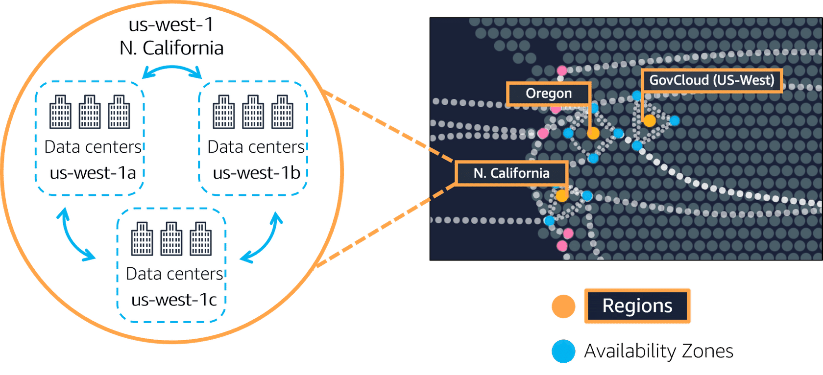

An **Availability Zone** is a single data center or a group of data centers within a Region. Availability Zones are located tens of miles apart from each other. This is close enough to have low latency (the time between when content requested and received) between Availability Zones. However, if a disaster occurs in one part of the Region, they are distant enough to reduce the chance that multiple Availability Zones are affected.

So here's the key points. Number one,

Regions are **1.geographically isolated areas,**

where you can access services needed to run your enterprise.

**2.Regions contain Availability Zones,**

that allow you to run across physically separated buildings, tens of miles of separation, while keeping your application logically unified. Availability Zones help you solve high availability and disaster recovery scenarios, without any additional effort on your part,

**3.AWS Edge locations run Amazon**

CloudFront to help get content closer to your customers, no matter where they are in the world.

**Edge locations**

An **edge location** is a site that Amazon CloudFront uses to store cached copies of your content closer to your customers for faster delivery.

# How to provision AWS resources:

For example, you can launch an EC2 instance or you can create an AWS Lambda function. Each of those would be different requests and different API calls to AWS. You can use the

**Ways to interact with AWS services**

**1.AWS Management Console,**

**2.the AWS Command Line Interface,**

**3.the AWS Software Development Kits,**

or various other tools like AWS CloudFormation, to create requests to send to AWS APIs to create and manage AWS resources.

**AWS Elastic Beanstalk**

With **AWS Elastic Beanstalk**, you provide code and configuration settings, and Elastic Beanstalk deploys the resources necessary to perform the following tasks:

* Adjust capacity
* Load balancing
* Automatic scaling
* Application health monitoring

**AWS CloudFormation**

With **AWS CloudFormation**, you can treat your infrastructure as code. This means that you can build an environment by writing lines of code instead of using the AWS Management Console to individually provision resources.

AWS CloudFormation provisions your resources in a safe, repeatable manner, enabling you to frequently build your infrastructure and applications without having to perform manual actions. It determines the right operations to perform when managing your stack and rolls back changes automatically if it detects errors.

**Amazon Virtual Private Cloud (Amazon VPC)**

Imagine the millions of customers who use AWS services. Also, imagine the millions of resources that these customers have created, such as Amazon EC2 instances. Without boundaries around all of these resources, network traffic would be able to flow between them unrestricted.

A networking service that you can use to establish boundaries around your AWS resources is [**Amazon Virtual Private Cloud (Amazon VPC)**](https://aws.amazon.com/vpc/).

**4.NETWORKIG…………**

**Internet gateway**

To allow public traffic from the internet to access your VPC, you attach an **internet gateway** to the VPC.

An internet gateway is a connection between a VPC and the internet. You can think of an internet gateway as being similar to a doorway that customers use to enter the coffee shop. Without an internet gateway, no one can access the resources within your VPC.

**Subnets and network access control lists**

WS has a wide range of tools that cover every layer of security: network hardening, application security, user identity, authentication and authorization, distributed denial-of-service or DDoS prevention, data integrity, encryption, much more.

**Network traffic in a VPC**

When a customer requests data from an application hosted in the AWS Cloud, this request is sent as a packet. A **packet** is a unit of data sent over the internet or a network.

It enters into a VPC through an internet gateway. Before a packet can enter into a subnet or exit from a subnet, it checks for permissions. These permissions indicate who sent the packet and how the packet is trying to communicate with the resources in a subnet.

The VPC component that checks packet permissions for subnets is a [**network access control list (ACL)**](https://docs.aws.amazon.com/vpc/latest/userguide/vpc-network-acls.html).

**Network access control lists (ACLs)**

A network access control list (ACL) is a virtual firewall that controls inbound and outbound traffic at the subnet level.

For example, step outside of the coffee shop and imagine that you are in an airport. In the airport, travelers are trying to enter into a different country. You can think of the travelers as packets and the passport control officer as a network ACL. The passport control officer checks travelers’ credentials when they are both entering and exiting out of the country. If a traveler is on an approved list, they are able to get through. However, if they are not on the approved list or are explicitly on a list of banned travelers, they cannot come in.

**Domain Name System (DNS)**

Suppose that AnyCompany has a website hosted in the AWS Cloud. Customers enter the web address into their browser, and they are able to access the website. This happens because of **Domain Name System (DNS)** resolution. DNS resolution involves a customer DNS resolver communicating with a company DNS server.

**Amazon Route 53**

[**Amazon Route 53**](https://aws.amazon.com/route53) is a DNS web service. It gives developers and businesses a reliable way to route end users to internet applications hosted in AWS.

Amazon Route 53 connects user requests to infrastructure running in AWS (such as Amazon EC2 instances and load balancers). It can route users to infrastructure outside of AWS.